
SECJ 2203: Software Engineering
Semester 01, 2024/2025

PROJECT PROPOSAL
XYZ SYSTEM
ABC ORGANIZATION
Team Name: <State the agreed name>

Team Members:
1. Member name (Indicate the role in the team e.g. Team Leader)
2.
3.
4.

Table of Contents

Item | Page No | Prepared by | Moderated by
- Introduction
- Existing Systems
- Proposed System
- Software Process Model
- Project Schedule
- References

- Introduction
Explain using NABC: the need (N), approach (A), benefit (B) and competitor (C) of the proposed system XYZ, as follows:
Need (N) | Specific need or problem that the proposed system, XYZ, addresses within the given domain. Provides strong and relevant evidence to support the need.
Approach (A) | Clearly laid-out plan for how the proposed system will work (eg: mobile app, cross-platforms, cloud-based, or uses AI/smart technology etc.), explaining how its main features operate in detail.
Benefit (B) | Significant benefits of the proposed system offer to the specific users.
Competitor (C) | Other similar products or solutions already available, emphasizing how the proposed system is different.
List the URL in the references (see Section 6) and cite here when stating the systems. The details of existing solutions or systems should be elaborated in Section 2 not here. References to other documents, books or related online resources must be properly cited in the text, written here as examples [1] and GitHub [2]. Provide at least three references (see Section 6) and cite accordingly. Organize the contents in paragraphs.

- Existing Systems
If no computerized system exists, do indicate the manual system. If an existing system exists and used by the stakeholders but it has some significant problems, describe an extension or changes to the existing system. Do include the screen shots of the existing system if it exists besides the current solutions available as stated in Section 1 and cite the source accordingly [3]. If the proposed system is better and should replace or extend existing system used by the users or better than those available in the market, explain and justify. Include at least two issues or problems of the existing system or current solutions by comparing their features in a table.
Table 1: Comparison of existing systems
Features | GitHub [2] | ABC [3] | DEF [4]
Feature 1 | Yes | No | No
…

- Proposed System
If the project is part of a larger system or if it must interface with some other software, and any other related information, explain in this section. Do provide a brief explanation of the system here by briefly explain the users’ roles and what they can perform via the system.

- Software Process Model
Choose the ideal software process model for the proposed system development and give justification on the chosen process model. Describe detailed activities covering software development life cycle (SDLC) that relevant to every phase of the chosen software process model. Determine the suitable duration for every phase and assign person in-charge (your team members). Also, propose the appropriate deliverables for every phase. Your team can assume the project is to be completed more than 14 weeks (5 working days per week) that is beyond this SECJ 2203 SE course scope with the assigned number of team members. Note that for the scope of this course; implementation and testing of final working version is not done but should be included in the schedule.

- Project Schedule
Illustrate the planned activities, duration and assigned person in-charge for the proposed project as a Gantt chart using any suitable project management tool.
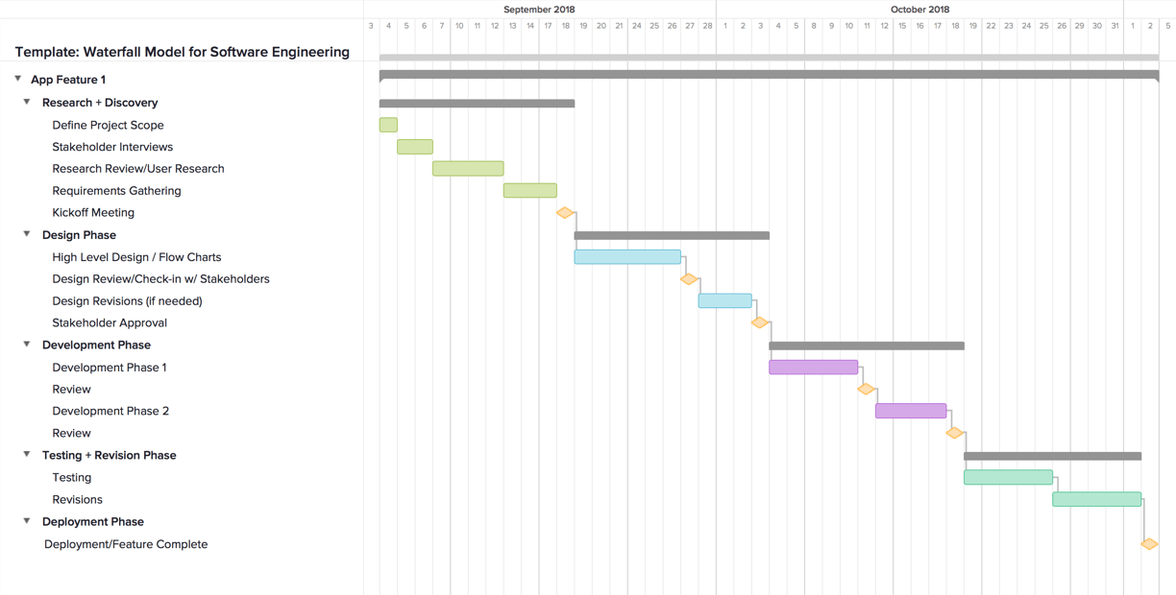
Figure 2: Gantt Chart Example
[URL : https://www.teamgantt.com/waterfall-model-template]

- References
- Sommerville, I. (2016). “Software Engineering”, 10th Edition, US: Pearson.
- GitHub. (2020). Retrieved from www.github.com
- …

Appendices
Include verifiable evidence of the use of Generative AI tools such as ChatGPT, QuillBot, etc., in the creation of your assignment. This evidence may include screenshots and URL links, which should be included in the appendices section. Failure to provide this evidence will result in ethical violations and may lead to plagiarism penalties, ultimately resulting in a grade deduction to zero marks.
* Generative Artificial Intelligence refers to a type of artificial intelligence technology that can produce various types of content, including text, images, audio, and synthetic data

Example: Screenshot
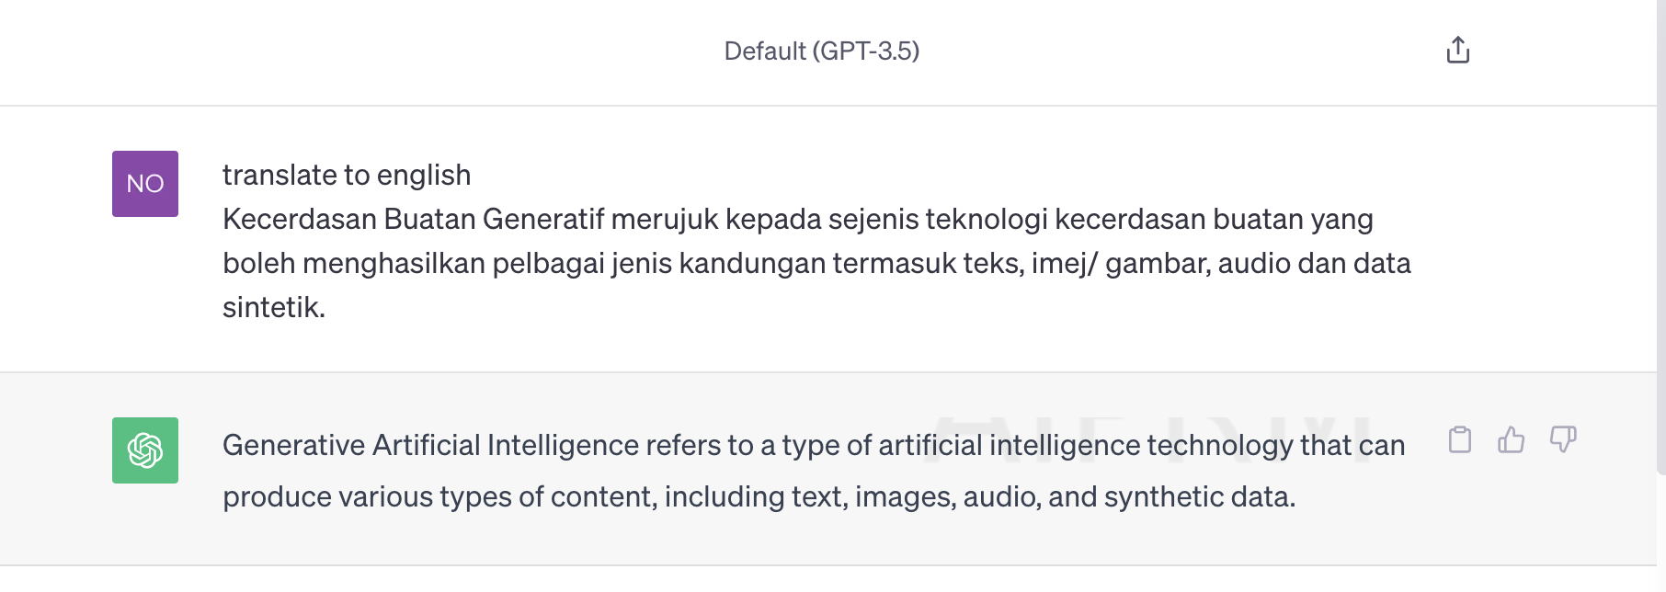
Figure: Screenshot Generative AI translation from BM to English
Example: URL
https://chat.openai.com/share/0ff33fdd-9b7f-407c-9b74-b744ec698a7e

Marking Criteria | Marks
Introduction  - Needs  - Approach  - Benefits  - Competitors | 12 marks
Existing Systems | 4 marks
Issues or problem with existing systems | 4 marks
Proposed System | 10 marks
Software Process Model  - Justification on choice | 5 marks
Software Process Model  - Detailed Activities | 10 marks
Software Process Model  - Deliverables and Duration | 5 marks
Project Schedule | 5 marks
References | 2 marks
Overall report quality | 3 marks
Report Total marks | 60 marks/5%
Team-working (Peer evaluation) | 0.5 %
Team-working (Instructor observation) | 0.5%

